Case Study on Amazon EC2 Web Services

Introduction
Amazon Elastic Compute Cloud (EC2) is a web service provided by Amazon Web Services (AWS) that allows users to create and manage virtual servers (instances) in the cloud. It eliminates the need for physical hardware and provides scalable, secure, and cost-effective computing resources.
EC2 enables users to launch instances with different configurations, connect to them remotely, and perform various computing tasks. In this case study, we performed hands-on operations such as launching an instance, connecting to it, installing a web server, hosting a webpage, and managing the instance lifecycle.

Objectives
- To understand the concept of cloud computing using AWS EC2
- To learn how to launch an EC2 instance
- To study instance configuration parameters
- To connect to an EC2 instance using browser-based SSH
- To execute basic Linux commands
- To install and configure Apache Web Server
- To deploy a static website on EC2 instance
- To manage instance lifecycle

Theory
Amazon EC2 provides resizable compute capacity in the cloud. It allows users to launch virtual machines called instances.
Key components:
- AMI (Amazon Machine Image)
It is a template containing OS and software (e.g., Amazon Linux 2023).
- Instance Type
Defines hardware configuration such as CPU, RAM (e.g., t3.micro).
- Key Pair
Used for secure login (public + private key).
- Security Group
Acts as a firewall controlling inbound and outbound traffic.
- VPC (Virtual Private Cloud)
A virtual network where instances are deployed.
- Public IP Address
Used to connect to the instance over the internet.
- EBS Volume
Storage attached to the instance
EC2 follows a pay-as-you-go model, meaning users are charged only for the resources they use.
Apache Web Server
- Apache is an open-source web server used to host websites
- It serves HTML files stored in /var/www/html
- It uses HTTP protocol (Port 80)

Practical Implementation
Step 1: Launching EC2 Instance
- Open AWS Console → EC2 Dashboard
- Click on Launch Instance
- Enter name: Practical1
- Select Amazon Linux 2023 AMI
- Choose instance type: t3.micro
- Keep default settings and launch instance
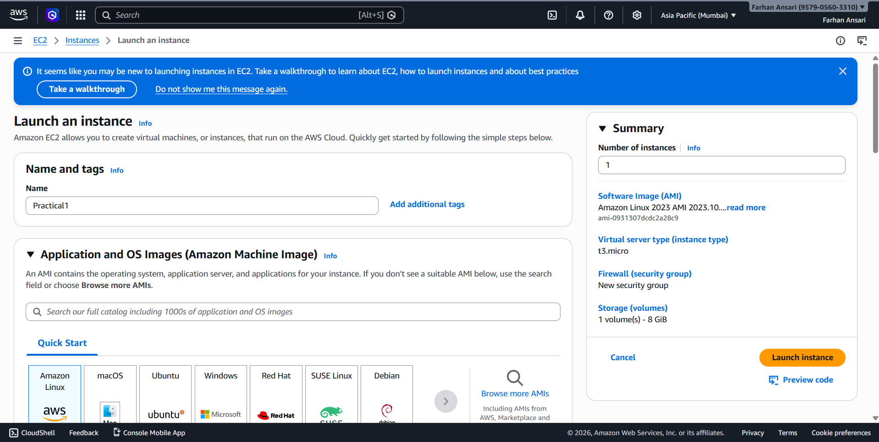
^{Launch Instance Page}
Step 2: Instance Successfully Running
- After launching, instance status becomes Running
- Status checks show 3/3 checks passed
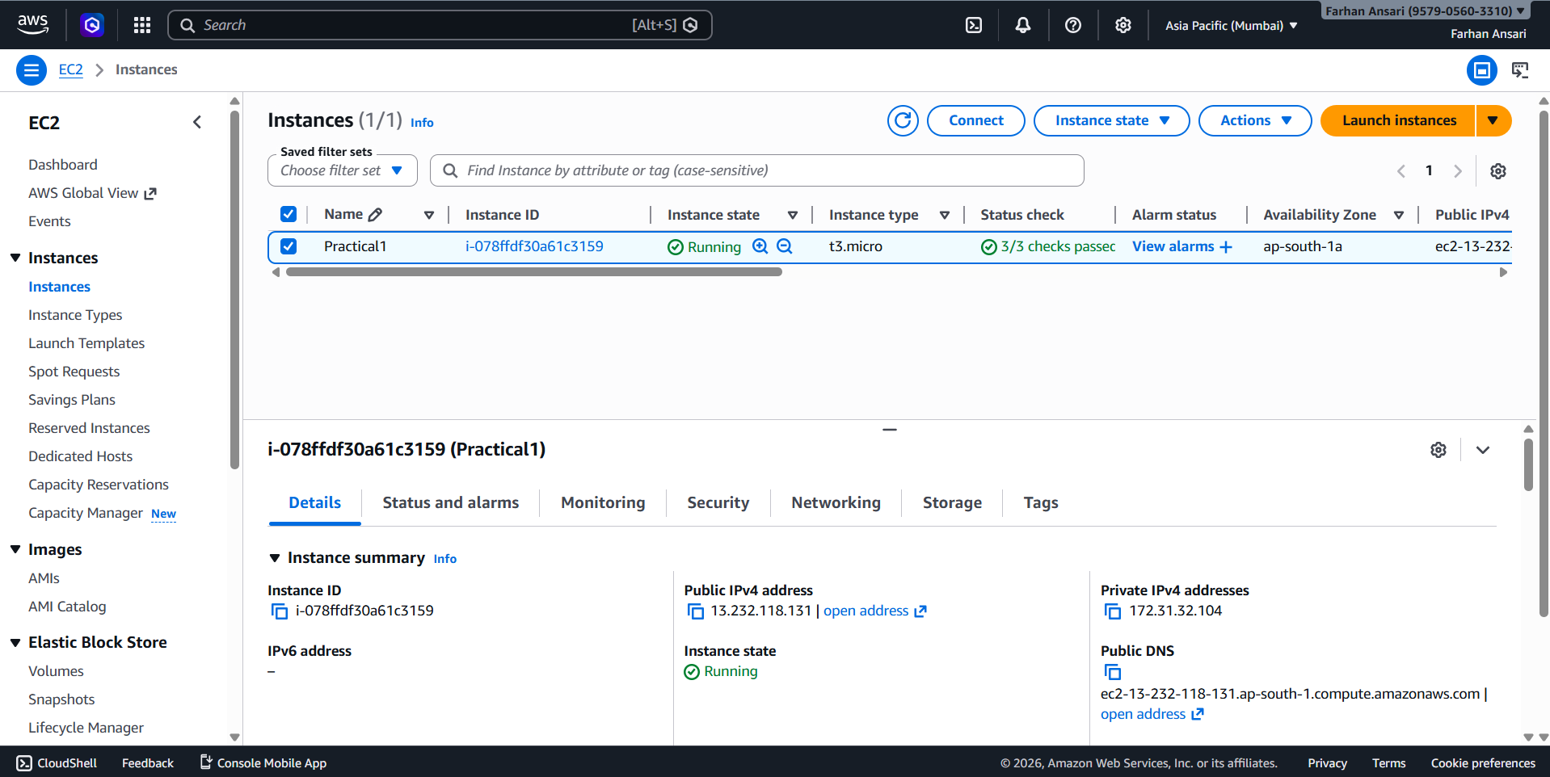
^{Instance Running}
Step 3: Viewing Instance Details
- Click on instance ID
- View details such as:
  - Instance ID
  - Public IPv4 address
  - Private IP
  - Instance type
  - Availability zone
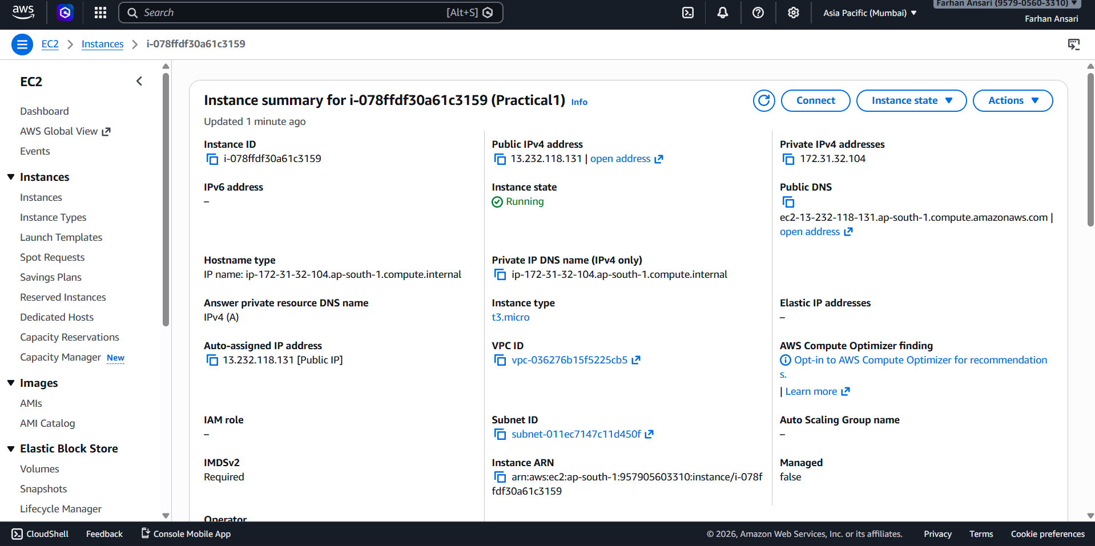
^{Instance Details}
Step 4: Connecting to EC2 Instance
- Click on Connect button
- Choose EC2 Instance Connect (browser-based)
- Username: ec2-user
- Click Connect

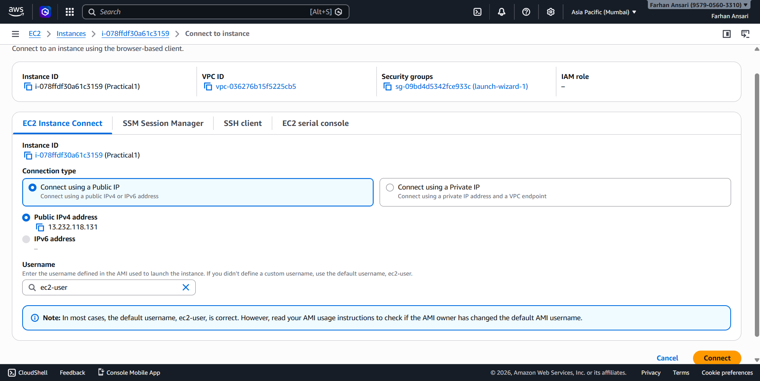
^{Connect Page}
Step 5: Installing Apache Web Server
Open terminal after connecting
Run:
sudo yum update -y
sudo yum install httpd -y
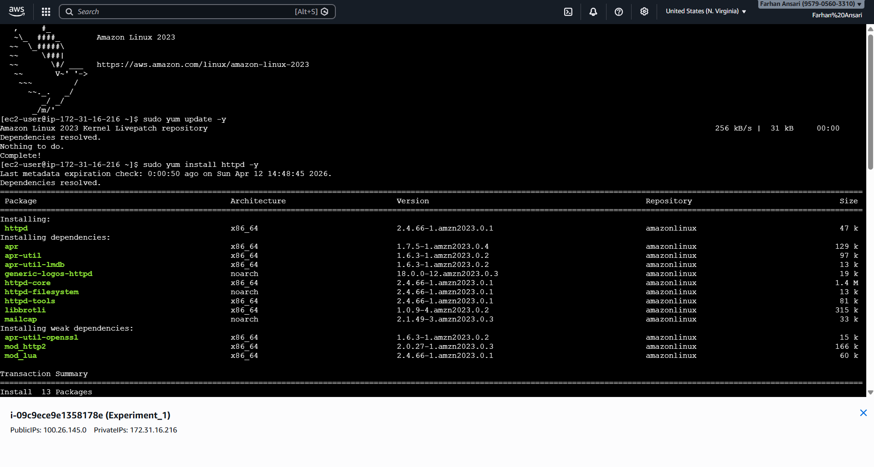 ^{Apache Installation}
Apache web server was installed successfully on the EC2 instance.
Step 6: Starting Apache Web Server
After installing Apache, the web server was started using the following commands:
- sudo systemctl start httpd
- sudo systemctl enable httpd
The start command runs the web server
The enable command ensures the server starts automatically after reboot
Step 7: Creating Website File
After starting the Apache server, a simple HTML webpage was created using the nano editor.
The following command was used: sudo nano /var/www/html/index.html
Then the following HTML code was written:
<html>
<head>
<title>My EC2 Website</title>
</head>
<body>
<h1>Hello from EC2 🎉</h1>
<p>This is my cloud computing practical.</p>
</body>
</html>
^{HTML File Creation}

Step 8: Accessing the Website
After creating the HTML file, the website was accessed using the public IP address of the EC2 instance.
The following URL was entered in the web browser: http://<Public-IP>
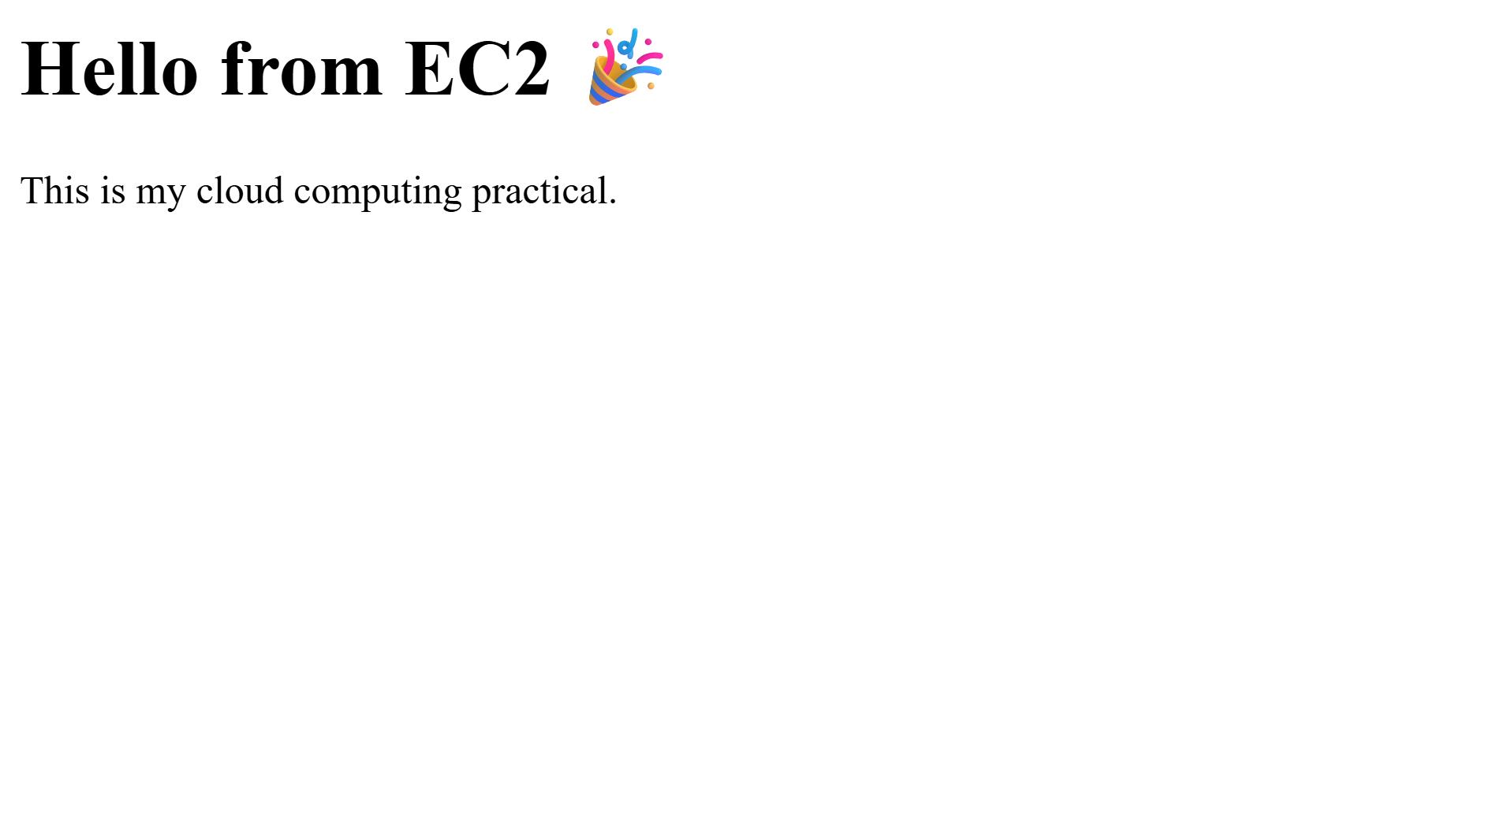 ^{Website Output}
HTTP (Port 80) was enabled in the security group to allow access to the website.
Step 9: Terminating the Instance
- Go to Instance State → Terminate Instance
- Confirm termination
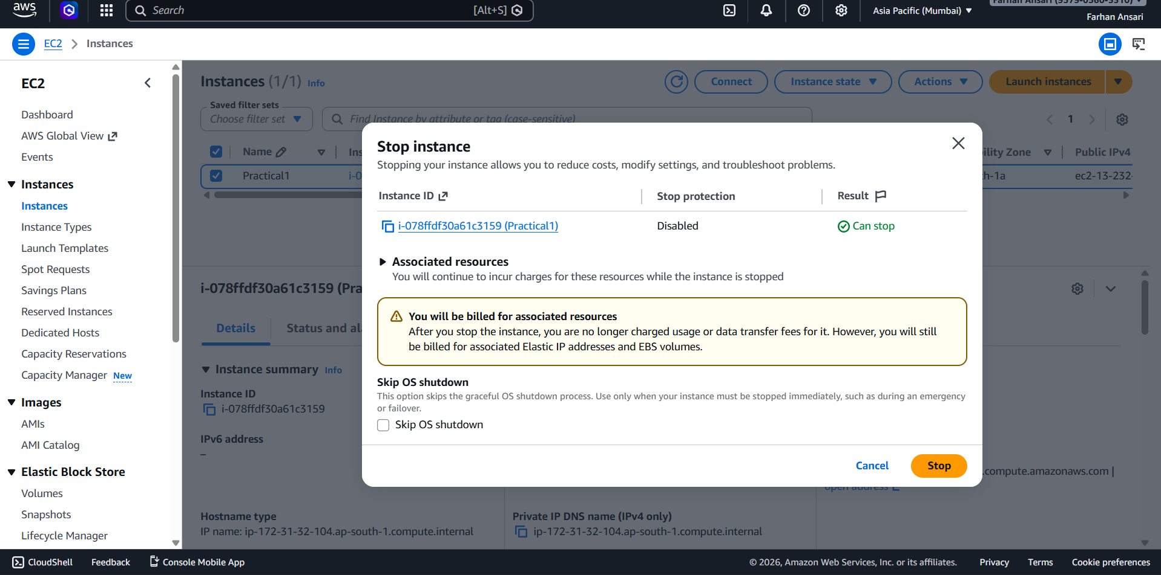
^{Instance Termination}

Step 10: Instance Stopped
- Instance state changes to Terminated
- Resources are deleted and no charges are incurred
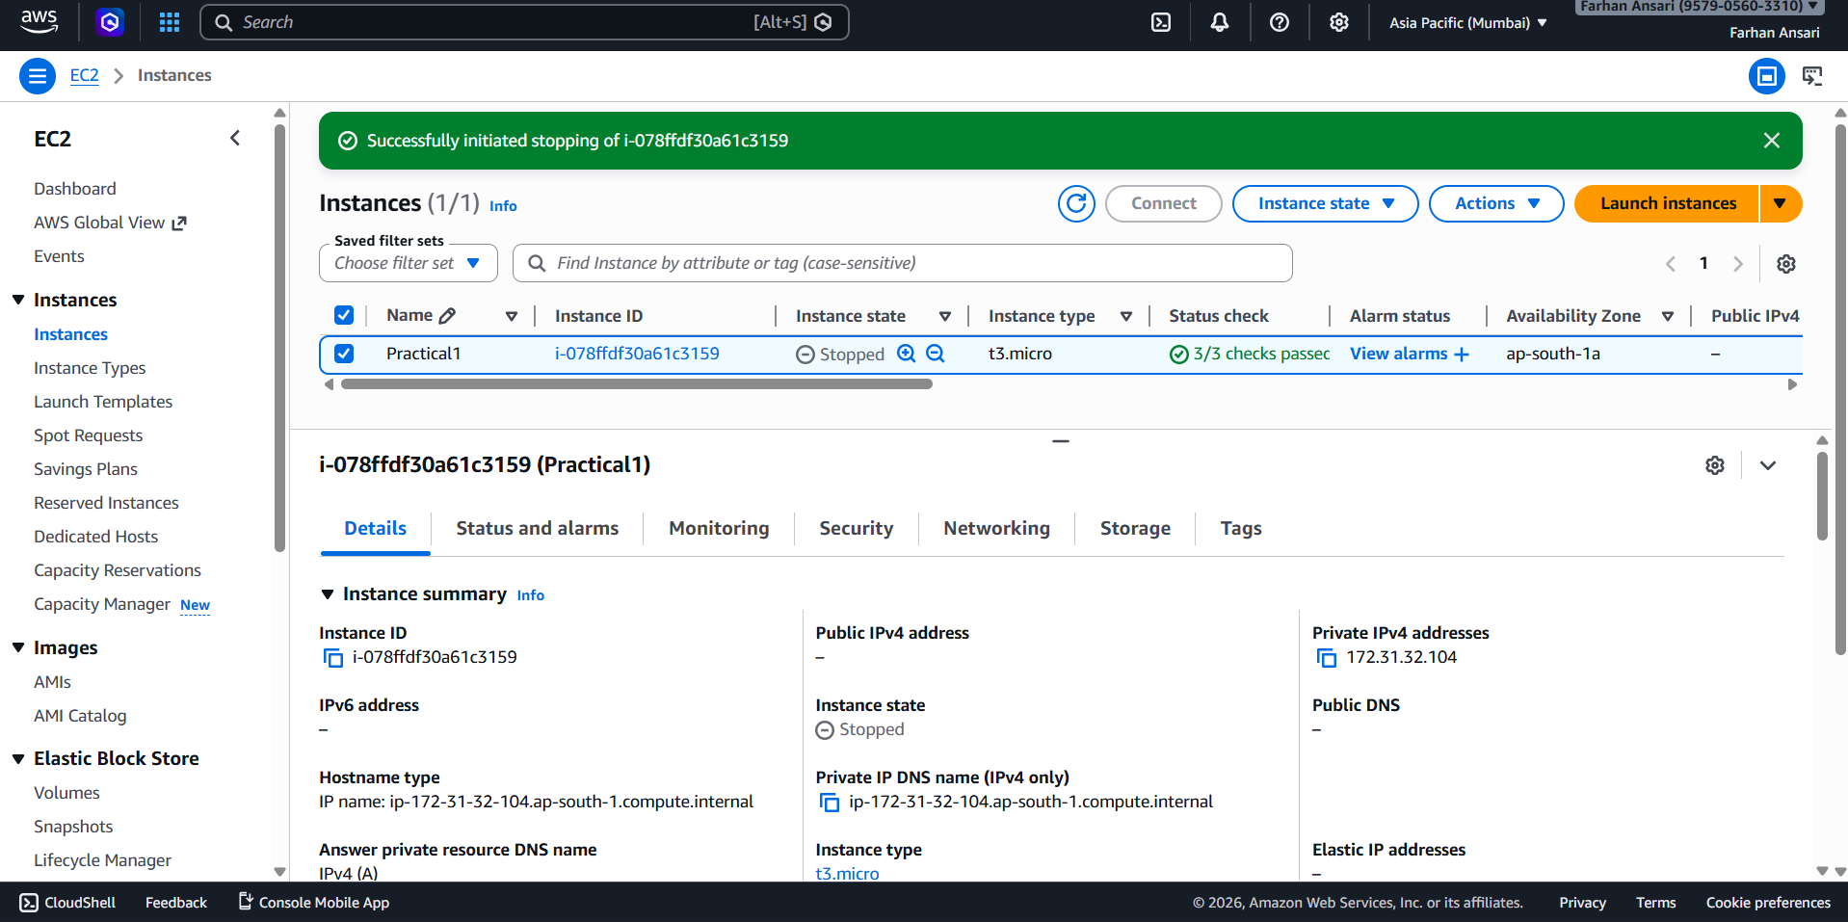
^{Instance Terminated}

Observations
- Instance launched successfully using default configuration
- Public IP assigned automatically
- Connection established without errors
- Linux commands executed correctly
- Instance lifecycle managed efficiently
- Apache web server installed and configured successfully
- Website hosted and accessed using public IP address

Advantages of Amazon EC2
- Scalable computing resources
- Easy to launch and manage instances
- Secure environment with security groups
- Pay-as-you-go pricing
- High availability and reliability

Limitations
- Requires internet connectivity
- Improper configuration may lead to security risks
- Charges may incur if instances are not stopped

Conclusion
In this case study, we successfully launched an EC2 instance, installed an Apache web server, and deployed a simple website accessible via public IP. This experiment provided hands-on experience with cloud computing, server configuration, and real-time web hosting using AWS EC2.

